CoulOak Baseball - Updating Game Scores
This is the process for updating and posting games scores on the Couloak.org web site. Division managers will be responsible for updating the scores in the system. Email carl@pantherfan.net if you have any questions or if you’re missing a web site permission.
Coach Instructions – At the end of each game the HOME TEAM COACH must email the game score, team names and game date to the Division Coordinator (aka division manager). NOTE: If the game is with another league, the Couloak Coach must send the score regardless of who the home team is. Please stick to email and not text so that we have a paper trail in case of a discrepancy.
Division Coordinators 2016:
Trevor Gibson - Majors - Trevor.Gibson@HeritagePrinting.com
Chad Crosby – Machine Pitch - chadtheworm@yahoo.com
Kevin Hogg - Minors - kevin.hogg@wellsfargo.com
_______________________________________________________________________________________

Division Manager Instructions - Update the scores at least twice a week so our stats are up to date for parents.
- Login to the Couloak site and click the SCHEDULES button on the blue menu bar
- Select your division in the scheduling group box. Select the game schedule in the scheduling event box and VIEW MATCHES. Next, select the game you want to edit.
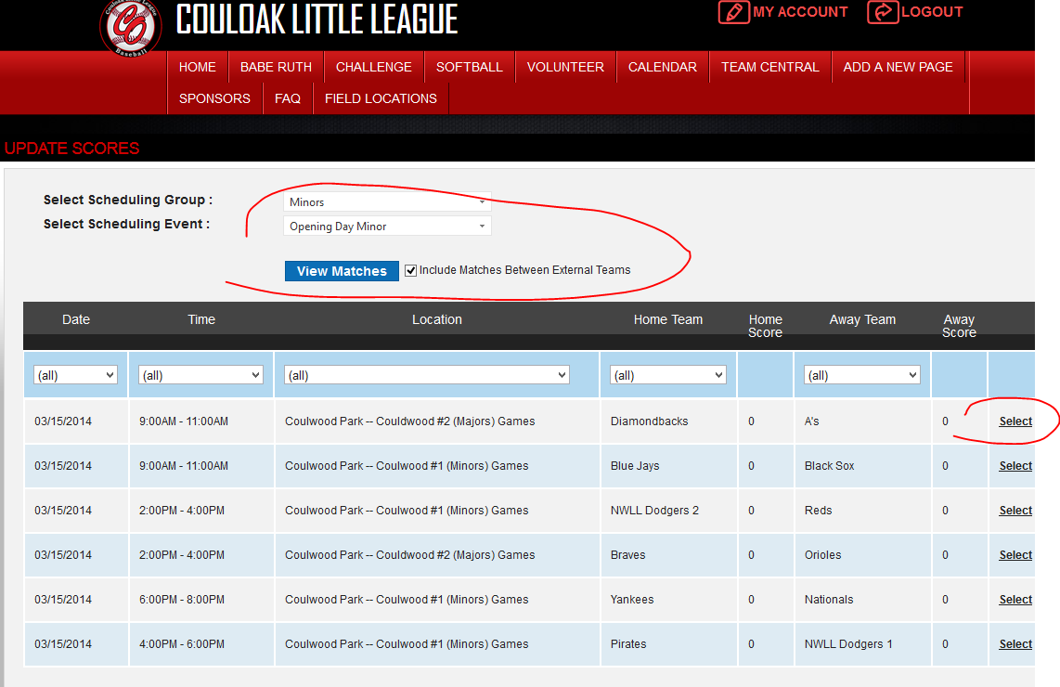
- Once you click the SELECT link, scroll down and you will see the score box, input the scores:
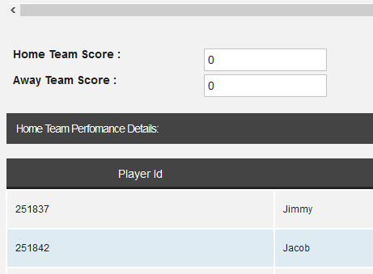

- Scroll to the VERY bottom of the page and hit the UPDATE button to save. Repeat for each team you are updating.
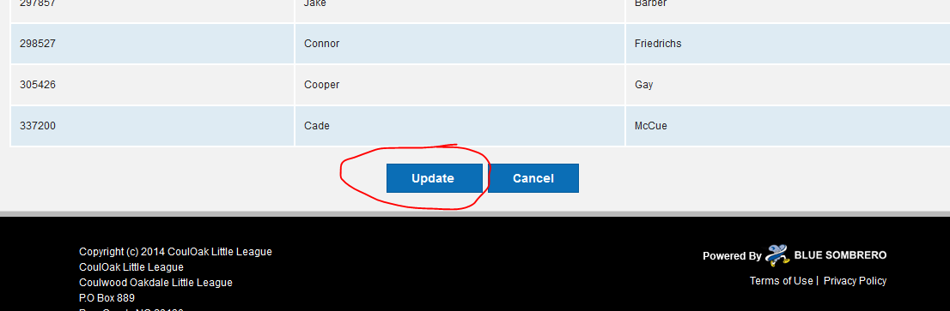
- POSTING SCORES: Now click on SCHEDULES/POST SCORES on the blue menu bar.
Select the scheduling group and event as you did before. Now select the games from the list that you want to POST or UNPOST. The ‘IsPosted’ column tells you if its been posted already or not. 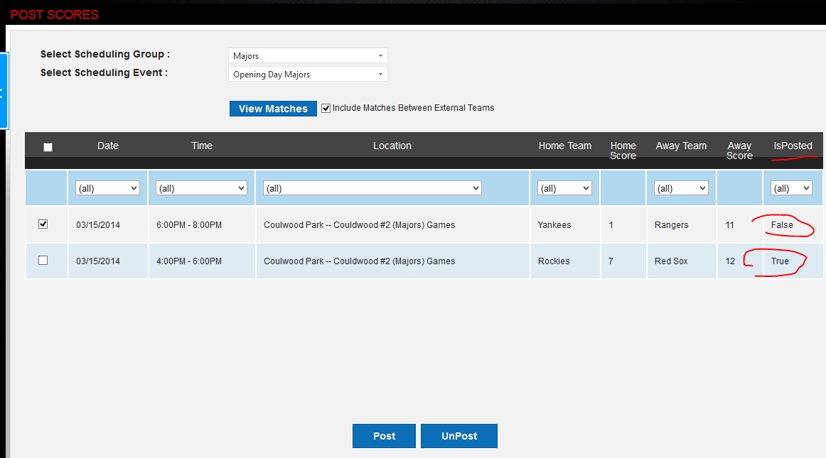
- Click POST or UNPOST when you are done making selections, you are done.

